**Title** Prismatic Heretic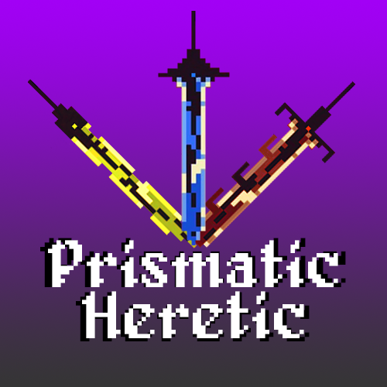

**Tag line** “Three swords, one heretic, no mercy”

**Your name** Sigma Squad

**Genre** Top-down, Hack-and-slash

**Platform** PC

**Market** Teen +



**Setting** High medieval fantasy, gothic academia

**Plays like** Enter the Gungeon meets Wizard of Legend

*Popular Game A Popular Game B or twist*



1. “Twin-stick” movement and aim 3. Leave weapons at your location to be activated later, remotely

2. Switch between 3 distinct weapons 4. Color-coded enemy types, resistant to matching-color weapons



1. [Enter the Gungeon](https://cdn.cloudflare.steamstatic.com/steam/apps/311690/ss_16e5c40621bfb6bfe2b9c010861850595e180e48.1920x1080.jpg?t=1622216602) (weapon use, pixel style) 4. [Dark Souls](https://mocah.org/uploads/posts/4533589-dark-souls-iii-video-games-castle-cathedral-bridge-moon-screen-shot-village-irithyll.png) (Atmosphere)

2. [Wizard of Legend](https://cdn.cloudflare.steamstatic.com/steam/apps/445980/ss_8efdb01e68a2c7a5d2c7570eaaebbb9322c4cdc9.1920x1080.jpg?t=1631898814) (pixel style, environment) 5. [Eldest Souls](https://www.pcinvasion.com/wp-content/uploads/2021/07/Eldest-Souls-quests-special-items-empty-vessel-rewards-guide-.jpg) (Art and inspiration)

3. [Legend of Zelda](https://cdn.gamer-network.net/2016/usgamer/zelda.png) (level layouts) 6. [The Binding of Isaac](https://www.makinggames.biz/wp-content/uploads/2015/05/binding-of-isaac-teaser-neu_9068.jpg) (View and angles)

**Related Games**

1. Enter the Gungeon Dodge Roll Roguelike Bullet Hell/Multiplatform 2016

*Title Publisher or Developer Genre/Platform Year*

Enter the Gungeon is a top-down roguelike bullet hell shooter. Enter the Gungeon’s aiming mechanic is the inspiration for Prismatic Heretic’s aiming system for the blades. Weapons in Prismatic Heretic are not strictly ranged or melee, but having a clear indicator for the direction of the player’s attacks is key; the weapon itself acts as an indicator, in addition to a traditional crosshair. In the heat of the action, where looking for a crosshair in the middle of a swarm of enemies and projectiles could cost the player their life, making the direction of attack be a big glowing sword originating from the player character should increase the readability of the mechanic.



2. Wizard of Legend Contingent 99 Roguelike H&S/Multiplatform 2018

*Title Publisher or Developer Genre/Platform Year*

Wizard of Legend is a top-down roguelike spellcasting action game. The intensity, pixel-based art style, and close-range combat of Wizard of Legend all play a role in the design of Prismatic Heretic. There aren’t any exact mechanics or art assets taken directly from this game, however it acts as an important source of inspiration when referencing the aesthetics and environmental design.

3. Legend of Zelda Nintendo Action Adventure Dungeon Crawl/NES 1986

*Title Publisher or Developer Genre/Platform Year*

Legend of Zelda is the first of its kind, a top-down action adventure dungeon crawling game where the player character’s strength and set of skills grows as the player progresses through the game. It is the great-great-grandfather of the genre, so nearly all of its mechanics can be found in some way in Prismatic Heretic. For example, enemies being resistant/invulnerable to specific weapons forces the player to be creative or change tactics; this is the moment-to-moment gameplay of Prismatic Heretic.



